2016

*Release 4.000.04*

Gregg Bursey

Scout Software Engineering

Table of Contents

1 Territories 3

2 Images CDN 3

3 Info Windows 3

4 Various Bug fixes 4

# Territories

Territories (either free drawn or chosen by geography) can be attached to an individual pushpin or store.

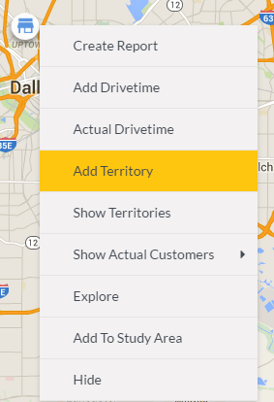

# Images CDN

All images for SCOUT, My Data, and Mobile are now being hosted from our CDN.

Benefits:

1. A central repository outside of our source control for all images
2. Consistent and static environment for images
3. Change images without code changes (should be rare – but still a benefit)

# Info Windows

**Before:**

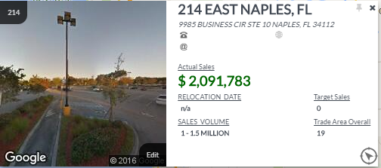

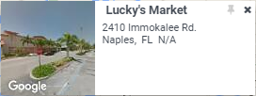

**After:**

*STORE:*

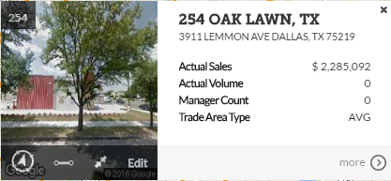

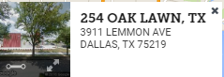

*PUSHPIN:*

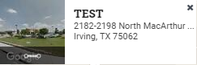

# Edit order of locations (drag and drop)

# Edit order of Actual Profiles (drag and drop)

# Active Logins fix (shows currently who is logged in)

# Mobile – minor drive time UI modification

# MyData – Browser tab title modification

# SCOUT – Results / AOI icon modifications (geographies

# Add geography to individual location (add label, value, text, colors, range, thematic)

# Various Bug fixes

Fixed active users status on dashboard to show current login status.

Various other bug fixes throughout the platform.